

Medication Adherence Tracker for Elderly Patients
A CASE STUDY ANALYSIS REPORT
Submitted in the partial fulfilment for the Course of
CSA1012-Software Engineering
to the award of the degree of
BACHELOR OF TECHNOLOGY
IN
Artificial Intelligence
Submitted by
P SADVIK(192472243)
Under Supervision of
Dr. k Anita Davamani
SIMATS ENGINEERING
Saveetha Institute of Medical and Technical Sciences
Chennai-602105
AUGUST-2026

1. Analyze System Requirements
1.1 System Objectives
The main objective is to help elderly patients remember medicines and help caregivers monitor medication status. The system should reduce forgotten doses and make a missed dose visible to the caregiver.
Provide a simple interface with large text and clear buttons.
Allow caregivers to manage medication schedules.
Send reminders when medicines are due.
Allow the patient to confirm a dose.
Store taken and missed dose records.
Alert the caregiver after a missed dose.
Provide medication history and refill reminders.
Protect patient information with login and access control.
1.2 Functional Requirements
Area | Requirement
Login | Patient and caregiver can log in.
Medication | Caregiver can add, edit and remove medicines.
Schedule | Medicine time and frequency can be stored.
Reminder | Patient receives a reminder when medicine is due.
Confirmation | Patient can press a simple Taken button.
Missed Dose | System marks an unconfirmed dose as missed.
Alert | Caregiver receives a missed-dose alert.
History | Previous dose records can be viewed.
Refill | System can show a refill reminder.
1.3 Non-Functional Requirements
The architecture is mainly influenced by usability, security, reliability, performance, availability, maintainability and scalability. Security is important because the system handles personal health-related information.

1.4 Quality Attributes Influencing the Architecture
Attribute | Effect on Architecture
Scalability | Separate application and database so capacity can grow.
Maintainability | Keep UI, application logic and data access separate.
Reliability | Store dose status so records are not lost.
Availability | Keep the application and reminder service available.
Performance | Use simple screens and efficient database operations.
Security | Use authentication and role-based access.
Usability | Use large controls, clear words and fewer steps.
1.5 Main Users
User | Responsibility
Elderly Patient | View reminders and confirm medicine.
Caregiver | Manage schedules and monitor adherence.
Healthcare Provider | May provide medication information.
Administrator | Manage accounts and settings.
1.6 System Boundary
The system is a reminder and tracking tool. It does not diagnose a disease, prescribe a medicine or decide that a dosage should be changed. Medication information is entered by an authorized caregiver or healthcare professional.
2. Select a Suitable Software Architecture
2.1 Selected Architecture
A simple layered architecture is selected. The main layers are Presentation, Application, Data Access and Data. A notification service works with the application layer for reminders and caregiver alerts.
2.2 Why Layered Architecture?
It is easy to understand and suitable for this capstone project.
Each layer has a clear responsibility.
UI changes can be made without changing database code.
Business rules can stay in the application layer.
Database changes have less effect on the UI.
Individual layers are easier to test and maintain.
2.3 Main Components
Component | Responsibility
Presentation Layer | Patient app and caregiver dashboard.
Application Layer | Scheduling, adherence, alerts and user operations.
Data Access Layer | Database read/write operations.
Data Layer | Stores users, medicines, schedules and dose history.
Notification Service | Sends reminders and missed-dose alerts.
A full microservices architecture was not selected because the first version is small. Microservices would add deployment and monitoring work without a major benefit at this stage.
3. Draw the Software Architecture Diagram
The diagram below shows the overall structure. The patient and caregiver use the interface, the application layer processes actions, the database stores records and the notification service sends reminders and alerts.
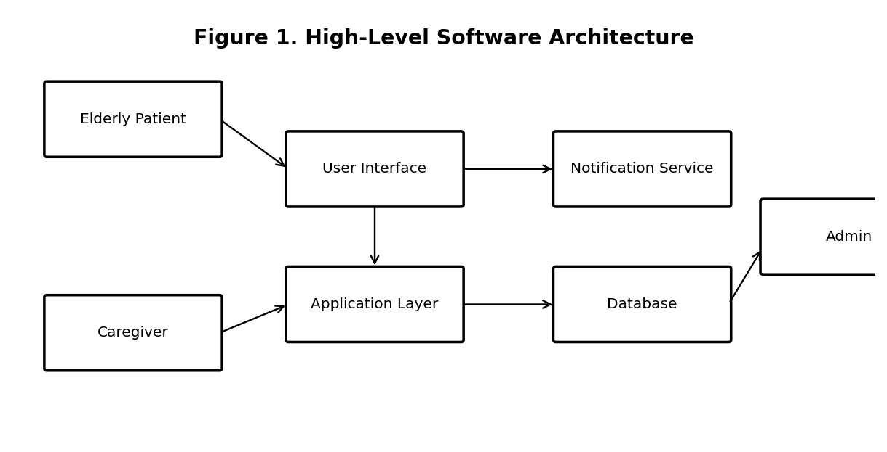
Figure 1. High-Level Software Architecture of the Medication Adherence Tracker
3.1 Communication
User actions enter through the interface.
Application logic checks and processes the request.
Data access layer communicates with the database.
Notification service handles reminders and alerts.
The result is shown to the correct user.
3.2 External Systems
The first version can use a normal notification service. Later, the system can connect to SMS, pharmacy systems, healthcare systems or smart pill boxes.3.3 Layered Architecture Diagram
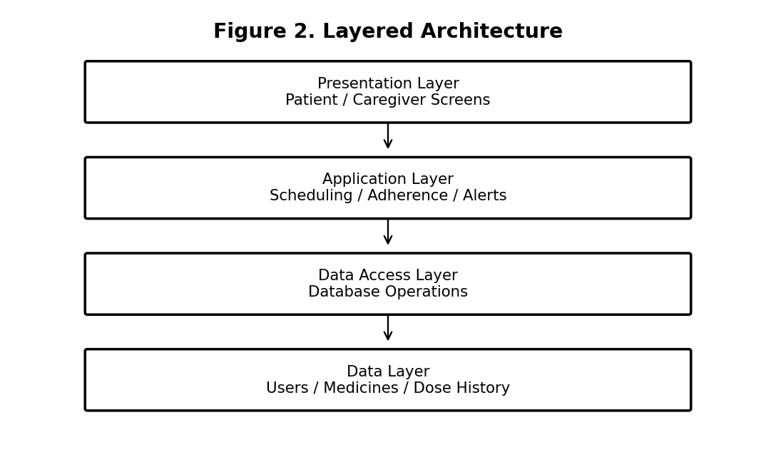
Figure 2. Layered Architecture Used for the System
3.4 Data Flow
For example, when a caregiver adds a medicine, the information goes from the screen to the application layer. The application checks the details and sends them through the data access layer to the database. The saved result is then shown to the caregiver.
For a reminder, the application checks the schedule. At the correct time it sends a notification. If the patient does not confirm within the selected period, the application changes the status to missed and creates an alert for the caregiver.
4. Explain Components and Their Interactions
4.1 Presentation Layer
This is the part used by patients and caregivers. The patient side should have large buttons, clear medicine names and minimum navigation. The caregiver side can show schedules, missed doses and history.
4.2 Application Layer
This is the main working part. It handles login rules, medication schedules, dose status, missed-dose checking, refill reminders and alert decisions.
4.3 Data Access Layer
This layer keeps database operations separate from the user interface and business rules. It provides functions for saving and reading information.
4.4 Database
The database stores user details, patient-caregiver relationships, medicine details, schedules, dose records and alerts.
4.5 Notification Service
This service sends medication reminders and caregiver alerts. The final implementation may use push notifications, SMS or email.
4.6 Administrator
The administrator manages accounts and system settings. Administrative access should not expose unnecessary patient information.
4.7 Overall Workflow
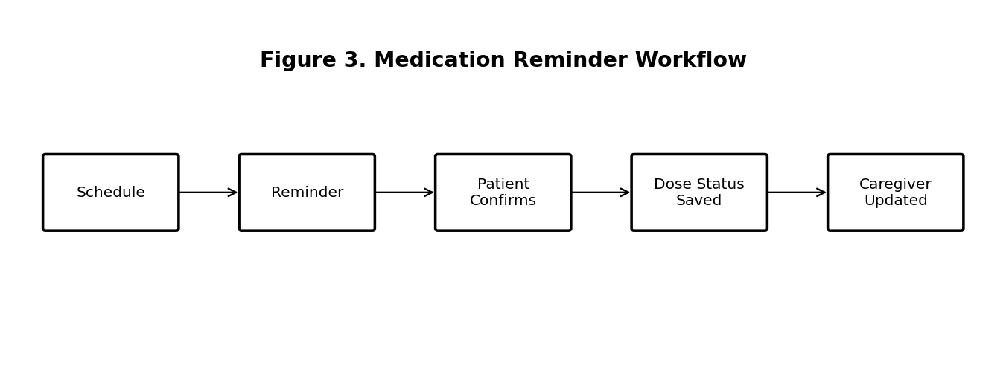
Figure 3. Medication Reminder and Confirmation Workflow
4.8 Example Interaction
Suppose a caregiver enters a medicine for 8:00 AM. The schedule is saved. At 8:00 AM the patient receives a reminder. After taking the medicine as prescribed, the patient presses Confirm. The system stores the confirmation time.
If the patient does not confirm within the defined period, the system marks the dose as missed and sends an alert to the caregiver. The caregiver can then check the situation.
4.9 Main Data Objects
Object | Examples of data
User | ID, name, role, login details
Medication | Name, dose, quantity
Schedule | Medicine, time, frequency, dates
Dose Record | Status, scheduled time, confirmation time
Alert | Type, receiver, time, delivery status
5. Discuss Quality Attributes
Attribute | Architecture Approach
Scalability | Separated layers make future expansion easier.
Security | Login and role-based access protect information.
Performance | Simple UI and direct data operations reduce delay.
Reliability | Dose records are stored in the database.
Maintainability | Separate layers make changes easier.
Availability | Application and notification service should be hosted reliably.
Usability | Patient screens use large controls and fewer steps.
5.1 Security
Only authorized users should view or change medication information. Passwords should be stored securely, not as plain text. Access should depend on the user role. Notifications should contain only the minimum information needed.
5.2 Performance
The application does not need heavy processing for normal operations. Keeping the interface simple and using indexed database fields for common searches can help the system respond quickly.
5.3 Reliability and Availability
Medication schedules and dose records should be saved safely. The application should also handle temporary notification failures and show the latest stored status when the user opens the system.
6. Justify Architectural Decisions
6.1 Reasons for the Selected Design
The layered architecture is a practical choice because the system is small enough to manage as one application but has different responsibilities. Separating the interface, application logic and data operations makes the project easier to understand, test and maintain.
6.2 Trade-Offs
Decision | Benefit | Trade-off
Layered design | Simple and maintainable. | Requests pass through more layers.
Central database | One place for medication history. | Must be protected and available.
Notification service | Useful for reminders and alerts. | Depends on connectivity.
Role-based access | Improves security. | Needs permission checks.
6.3 Future Enhancements
Voice-based medicine confirmation.
Multiple language support.
SMS or phone-call escalation.
Smart pill-box integration.
Pharmacy refill integration.
Healthcare-provider integration.
Offline support for mobile use.
Adherence charts and reports.
6.4 Conclusion
The proposed architecture matches the main needs of the Medication Adherence Tracker. The layered design keeps the system simple while separating the user interface, application functions and database. It also leaves room for future features such as voice confirmation, pharmacy integration and smart devices.
Reference: Assigned problem statement and the supplied Architecture Design Analysis question sheet.
END OF REPORT

